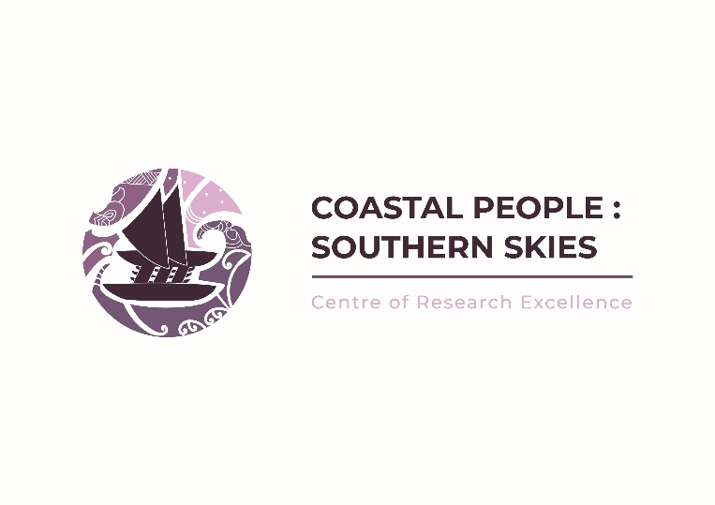
Expressions of Interest
The Coastal People: Southern Skies Centre of Research Excellence (CPSS) invites Expressions of Interest (EOI) in research projects that strengthen the mauri ora (flourishing wellness) of our coastal communities, restore and sustain coastal ecosystems, and grow the capability and capacity of our people. This call is the first step in a two-stage application process.
In this round we are looking for projects that demonstrate research excellence, and we encourage projects that:
- Are led by iwi, hapū, Pacific communities and community anchor sites
- Foster genuine partnerships with iwi, hapū, and community anchor sites
- Embody cross-disciplinary and cross-institutional collaboration
- Explore innovative approaches to restoring coastal ecosystems
- Improve our understanding of a rapidly changing environment
- Build capability and capacity for the next generation of coastal researchers

The Process
The process for this round of CPSS funding will involve two application stages, as set out in the diagram below. CPSS’s Ki Te Hoe Research Committee will be available through wānanga and one on one discussions with potential applicants to discuss your kaupapa. Submissions, either written or via video, will be received up until the closing date. EOI submissions will be reviewed by Ki te Hoe, to assess alignment with the CPSS vision, goals, and outcomes, and the guiding principles listed in the CPSS Information Sheet. Ki Te Hoe may connect projects with overlapping kaupapa, and encourage collaboration across organisations. Following review, applicants whose EOIs are successful will be invited to submit a full proposal.
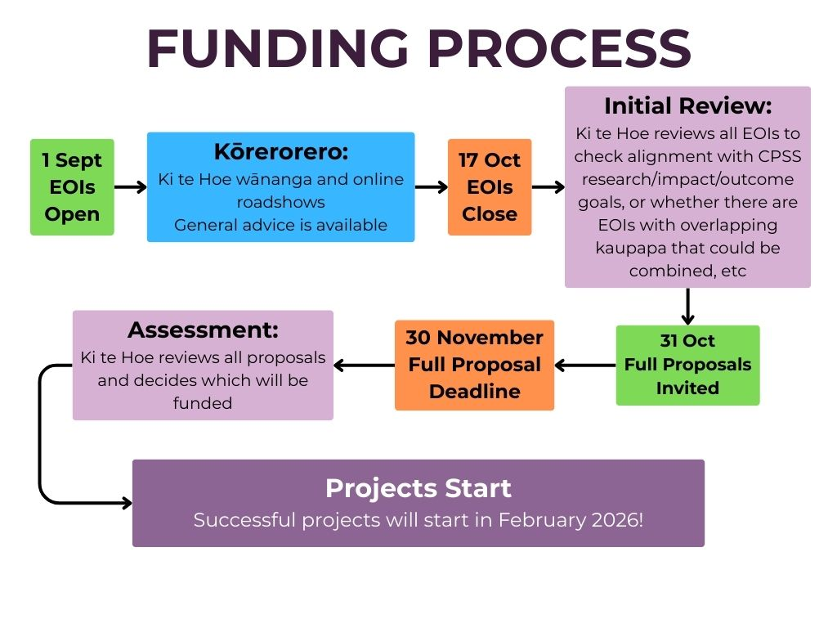

- Expressions of Interest
EOIs should outline the key details of your idea, including your main research kaupapa, members of your rōpū/research team, alignment with the platform Themes and Tumu of CPSS, any communities you will be working with, the geographic location and reach of your project, and should demonstrate research excellence.
We are especially interested in projects in the areas that give effect to the impacts below but would welcome EOI’s addressing any other aspects of our vision, Mauri ora of coastal communities. See the Information Sheet (page 11-13) for more information on CPSS Impacts and Outcomes.
High Priority:
- Give effect to Te Tiriti o Waitangi through the creation of Māori leadership opportunities.
- Advance and accelerate outcomes for Māori within the Aotearoa New Zealand education system including contributing to the revitalisation of te reo Māori.
- Enhance the educational achievements of Māori and Pasifika peoples.
- Strengthen research, education and industry connections between Aotearoa New Zealand and the nations of the Pacific.
Medium Priority:
- Enable coastal communities in Aotearoa New Zealand and the Pacific to manage the impacts of climate change locally.
- Understand the health, wellbeing and way of life of coastal people.
- Model and lead in the development of definitions of equity that are fit for purpose for coastal communities, including Māori, Pacific and rural peoples.
- Create vocational and educational opportunities for rural communities.
- Provide research to support policy and legislation development and decision making in Aotearoa New Zealand and the Pacific.
- Building collective models of successful research practice from the conception of the research, through the process, results and beyond for researchers and communities.
- Make a significant contribution to capability development for government, community, industry, and those entering the workforce through the provision of high-quality training and the application of research in a multidisciplinary context. Enable Aotearoa New Zealand to become a recognised leader in transitioning to a blue economy.
To submit an EOI, please use the form below. In the section describing your research kaupapa (Part D), you can submit a short video (no longer than five minutes) that provides key details and a summary of your research project, or you can provide a written description that must be 500 words or less.
We invite applications for research projects that are up to two and a half years in duration. The budget range for projects is $200-$300k in total, however, we are open to receiving applications that fall outside of this range.
- Invitation to submit a Full Proposal
Once Ki te Hoe has reviewed the expressions of interest, they will advise all applicants of the outcome and invite successful projects to submit a full proposal. The full process for this will be discussed with applicants but will involve sharing a more detailed description of the planned research, including research methods, budget, and any expected outputs/outcomes of the research.
Please submit all EOIs to cpss@otago.ac.nz by 17 October 2025
For any queries, please contact cpss@otago.ac.nz

PART A: Project Details
Project Title
Project Leader
Email |  | Phone
Organisation
Iwi/hapū/Community site (if applicable)
Geographic extent and reach of research (if applicable)

PART B: Investigator Details
Name | Organisation | Iwi/Pacific ethnicity | Role on Project | FTE (estimated)

PART C: Partner Organisations & Stakeholders
Please list any partner organisations and stakeholders you intend to work with on this research project. This may include community groups, hapū, iwi, or research organisations. We encourage applications where these relationships are already established and where community, hapū and iwi are leading or meaningfully engaged in the research from the outset.
Organisation | Contact Person

PART D: Research Kaupapa
Please provide a short summary of your research kaupapa, including key methods you will use, community engagement, and proposed outcomes. Include members of your rōpū/research team, any communities you will be working with and the geographic location/ extent of your project, if applicable (500 words or less).
Please identify which of the CPSS Themes and Tumu your project aligns with (see Expression of Interest Information sheet page 6-7).
☐Connecting Platform  ☐Restoring Platform  ☐Monitoring Platform |  | ☐Training Tumu  ☐Monitoring Tumu
The existing research waka has two foundations: a Marine hull and a Wellbeing hull. As part of CPSS balancing the waka (page 3, 5) please indicate alignment of the proposed research with the existing research hulls. Please provide a percentage that reflects your research alignment.
MARINE | WELLBEING |  | TOTAL
% | % |  | 100%
Which areas of the CPSS Impacts does your research project align with? See the Information Sheet (page 11-13) for more information. Please select any that apply.
☐Local climate change management: Enable coastal communities in Aotearoa New Zealand and the Pacific to manage the impacts of climate change locally.
☐Māori leadership development: Give effect to Te Tiriti o Waitangi through the creation of Māori leadership opportunities.
☐Understand wellbeing: Understand the health, wellbeing and way of life of coastal people.
☐Equity for coastal communities: Model and lead in the development of definitions of equity that are fit for purpose for coastal communities, including Māori, Pacific and rural peoples.
☐Advance outcomes for Māori: Advance and accelerate outcomes for Māori within the Aotearoa New Zealand education system including contributing to the revitalisation of te reo Māori.
☐Increased Māori and Pasifika educational achievement: Enhance the educational achievements of Māori and Pasifika peoples.
☐Opportunities for rural communities: Create vocational and educational opportunities for rural communities.
☐Inform policy, legislation and decision making: Provide research to support policy and legislation development and decision making in Aotearoa New Zealand and the Pacific.
☐Model successful research practice: Building collective models of successful research practice from the conception of the research, through the process, results and beyond for researchers and communities.
☐Stronger connection with nations of the Pacific: Strengthen research, education and industry connections between Aotearoa New Zealand and the nations of the Pacific.
☐Capability development: Make a significant contribution to capability development for government, community, industry, and those entering the workforce through the provision of high-quality training and the application of research in a multidisciplinary context.
☐Blue economy leader: Enable Aotearoa New Zealand to become a recognised leader in transitioning to a blue economy.

PART E: Budget
Please provide a short indicative budget for your project. Note an indicative budget range for projects is between $200-$300k in total. Projects must be completed within 2.5 years of contracting.

